Evaluation of the impact of EU funds on the economy of Latvia
Procurement Nr. FM2010/15 – TP
Second deliverable

Commissioned by:
Ministry of Finance of the Republic of Latvia
Smilšu iela 1
Rīga LV-1919

Contractor:
Stockholm School of Economics in Riga
Strēlnieku iela 4a
Rīga LV-1010

Partners:
Baltic International Centre for Economic Policy Studies
Strēlnieku iela 4a
Rīga LV-1010

Ernst & Young Baltic
Muitas iela 1A
Rīga LV-1010

December 2011
Riga

Table of Contents
1. Modelling approach 3
1.1. Short description of the structure of the model 4
2. Inclusion of funds in the model 4
2.1. Fund classification 4
2.2. Methodology for modelling the impact of funds 8
3. Results 10
3.1. The impact of funds of the 2004-2006 and 2007-2013 planning periods on the main macroeconomic indicators 10
3.2. The impact of funds by priority 16
4. Conclusions 21
Bibliography 23
Annex 24

Modelling approach
Within the framework of European Union (EU) Cohesion Policy, Latvia as an EU member state has received and will continue to receive substantial funds, aimed at increasing the production potential of its economy. The funds thus received were invested in various segments of the economy: fixed assets; infrastructure development; human capital; and technology. The evaluation of the impact of such investment is a complicated task for two main reasons. Such investment has both a long-term effect, which manifests itself in a greater productive capacity of the economy, and a short-term effect, which acts through the demand side of the economy and may benefit both the sector in which investment is made and other sectors. Additionally, investment in one sector may indirectly affect other sectors even in the long term. For example, the construction of a new road increases the output of the construction sector, which directly affects the demand for labour and the wage levels in that sector. At the same time, a better road network potentially increases productivity (including labour productivity) in all sectors of the economy, and it can therefore be expected that an indirect effect of better road infrastructure is, for example, higher overall wage levels, which would lead to more demand both for goods produced domestically and for goods imported.
When modelling the impact of funds investment, taking account of these mechanisms and of the interrelationships between the various segments of the economy in a consistent manner requires an appropriate economic model. There is a considerable literature on the evaluation of EU structural policies based on macroeconomic models (an overview of simulation models used in the ex-ante evaluation of EU funds is provided by Lolos (2011)). For Latvia, an evaluation of the impact of EU structural policy using macroeconomic modelling was first done in 2000, when the HERMIN model was developed for modelling the ex-ante effect of pre-accession EU funds (Bradley et al, 2000). In 2007-2008, the LATFUN model was developed for the ex-ante and ex-post evaluation of pre-accession funds and EU funds that Latvia received or expected to receive after 2004 (BICEPS, 2008a and 2008b).
The macroeconomic model developed within the framework of this project has a number of advantages compared with the earlier HERMIN and LATFUN models. First of all, the model equations are fully based on econometric estimations, without calibration of short-term parameters; this provides better model in-sample fit. Secondly, the sectorial interrelationships have been estimated econometrically and rather than using input-output tables as in the HERMIN and LATFUN models. Input-output tables are available with a very long time-lag and for an economy such as Latvia which has experienced substantial structural changes in the past few years, it seems more appropriate to use an approach that is based on an empirical estimation. Lastly, this model minimises the use of dummy variables as possible, even though the equation parameters were estimated on data for the period including the 2008 crisis. This increases the robustness of the model. We tested model robustness as part of the project itself: initially, we estimated equation parameters for the period up to the fourth quarter of 2010, but in the second stage of the project we re-estimated the equations for the period up to the first quarter of 2011, and this had no significant effect on model stability.

Short description of the structure of the model
We look at five sectors on the supply side.
1. Agriculture (AB-sector, including NACE sectors A and B).
2. Industry (CE-sector, including NACE sectors C, D, and E).
3. Construction (F-sector, including NACE sector F).
4. Private services (GK-sector, including NACE sectors G, H, I, J, and K).
5. Public services (LP-sector, including NACE sectors L, O, and P).
On the demand side, we model private consumption, public consumption, investment, exports and imports, leaving changes in inventories as the residual. The model consists of 149 equations (including equations that describe EU fund variables) and 33 exogenous variables. A more detailed description of the model structure is available in the report of the first deliverable.

Inclusion of funds in the model

Fund classification
In accordance with terms of reference, this evaluation covers the following financial instruments: European Social Fund, European Regional Development Fund, Cohesion Fund/ISPA, European Agricultural Fund for Rural Development, European Fisheries Fund, European pre-accession financial instruments Phare and SAPARD, INTERREG, Objective 3 “Territorial Cooperation” of the EU Cohesion Policy (ERAF), financial instrument of the European Economic Area, Norwegian Bilateral Financial Instrument, Swiss-Latvian cooperation programme. The above financial instruments are referred to as “funds” in the text below.
We classify fund investments according to three criteria. Firstly, we classify fund investment according to its effect on the production function, which allows us to evaluate the long-term impact of the funds on production capacity; the categories are investment in infrastructure (A-type expenditures), investment in technology (F-type expenditures), investment in fixed capital (K-type expenditures), and investment in human capital (L-type expenditures). Secondly, bearing in mind that we model five sectors on the supply side, we assign the respective NACE codes to fund expenditures.
Lastly, we attribute fund investment to one of the priorities. The analysed priorities have been agreed with the Finance Ministry and correspond to the terms of reference. The impact of the funds is analysed in two periods: 2004-2006 programming period and 2007-2013 programming period. The funds which had different planning periods (e.g. Norwegian Bilateral Financial Instrument) also have been added to one of the programming periods.
In the 2004-2006 programming period, the EU structural funds are analysed according to 4 priorities:
1. Promotion of territorial cohesion
2. Promotion of enterprise and innovations
3. Development of human resources and promotion of employment
4. Promotion of development of agriculture and fisheries.
Apart from the EU structural funds, the 2004-2006 period includes INTERREG, Phare and SAPARD.
The 2007-2013 period is analysed according to eight priorities and includes EU structural funds of the 2007-2013 programming period, European Agricultural Fund for Rural Development and European Fisheries Fund. The table presenting matching between the analysed eight priorities and priorities determined in EC Regulation 1828/2006, agreed with the Finance Ministry, is included in Annex (table P.1). The analysed 8 priorities are:
1. Research and technology development
2. Innovations and entrepreneurship
3. Information society
4. Transport
5. Energy
6. Environmental protection and risk reduction
7. Human capital, employment, social integration
8. Education
Apart from the above mentioned funds, 2007-2013 period includes Objective 3 “Territorial Cooperation” of the EU Cohesion Policy, Norwegian Bilateral Financial Instrument and Swiss-Latvian cooperation programme.
Figure 2.1 shows the structure of fund investment according by economic categories from 2001 (the year in which Latvia began to receive pre-accession funds) to 2015 (according to the so-called n+2 rule, funds of the 2007-2013 planning period may be used until 2015, inclusive). It can be seen that the bulk of investment was geared towards infrastructure development, with A-type expenditures making up 50% of total investment over the whole period. The second most significant category of investment is investment in fixed capital (about 36% of all investment). Investment in human capital constitutes about 10%, but investment in the development of new technologies—slightly more than 4%.
Figure 2.1: Fund investment by economic category in 2001-2015, % of total*
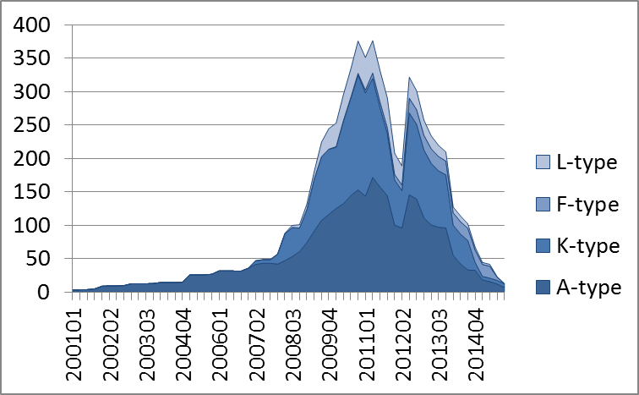
* All analysed financial instruments are included. Includes fund financing, public and private co-financing.
Source: authors’ calculations
The split of investment by NACE sector is more uniform (see Figure 2.2). Investment in industry (CE-sector) receives the greatest share (30%) of total investment, followed by investment in construction (F-sector), private services (GK-sector), and public services (LP-sector), with the last three categories receiving about 18-19% of total investment each. Investment in agriculture (AB-sector) constitutes slightly more than 10%. However, if the relative size of the sectors is taken into account, the construction sector receives a disproportionate share of all investment, while private and public services receive a relatively small fraction.
Figure 2.2: Fund investment by NACE sector in 2001-2015, % of total*
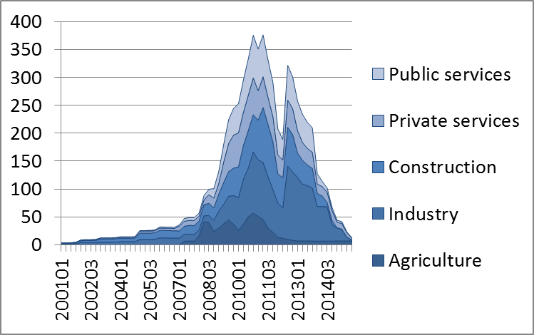
* All analysed financial instruments are included. Includes fund financing, public and private co-financing.
Source: authors’ calculations
Looked at by priority, fund expenditure in the 2004-2006 planning period was greatest on investments that aimed at promoting territorial cohesion, promoting entrepreneurship and innovations, and promoting agriculture and fisheries. These priorities accounted for more than a third of all fund expenditure over the planning period (see Figure 2.3). In the 2007-2013 planning period, the greatest part of fund investment was geared towards innovations and entrepreneurship, transport, environmental protection and environmental risk reduction, as well as towards promoting human capital, employment, and social integration, with these priorities accounting for 80% of all fund investment in the 2007-2013 planning period.
Figure 2.3: Fund expenditure by priority in 2004-2006 and 2007-2013 planning period, % of total fund expenditure in the respective period*
2004-2006 planning period** | 2007-2013 planning period***
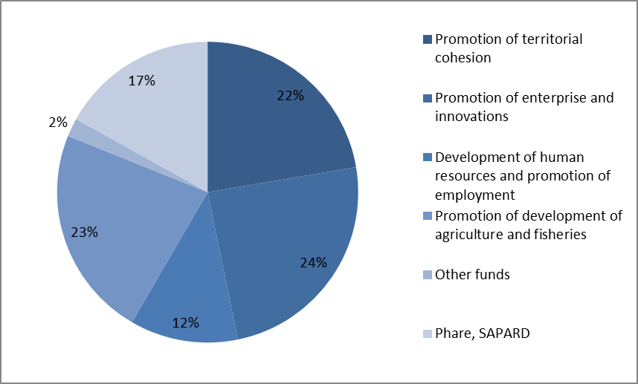 | 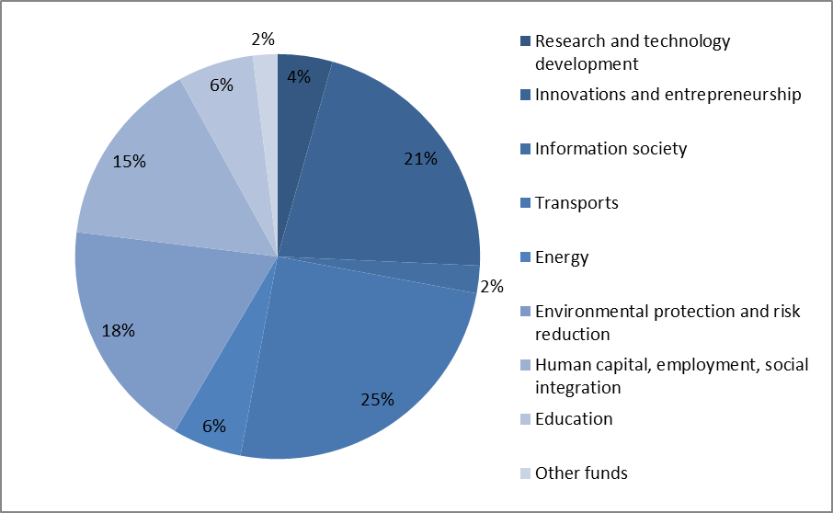
* All analysed financial instruments are included. Includes fund financing, public and private co-financing.
** Other funds include technical assistance and INTERREG
*** Other funds include objective 3 “Territorial Cooperation” of the EU Cohesion Policy, Norwegian Bilateral Financial Instrument and Swiss-Latvian cooperation programme.
Source: authors’ calculations

Methodology for modelling the impact of funds
The model allows us to analyse both the demand-side effect created by funds, which arises in the short term as fund investment flows into the economy, and the supply-side effect, which manifests itself over a longer period, as fund investment increases the productive capacity of the economy. For modelling the effect of funds, we use a methodology similar to that of Bradley et al. (2000) and BICEPS (2008a).
Supply-side effects
We assume that fund investment increases the stock of accumulated capital in the economy: A-type expenditure promotes infrastructure development; F-type expenditure promotes the development of technology; K-type expenditure increases accumulated fixed capital; finally, L-type expenditure increases accumulated human capital. To evaluate the impact of accumulated capital on productive potential, it is necessary to make assumptions about the levels of accumulated capital that would prevail in the absence of fund investment. With regard to infrastructure and technology, we assume that in a scenario without fund inflows infrastructure and technology capital is formed out of public sector investment. Accumulated fixed capital in each sector evolves out of the investment made in that sector. Human capital is equal to the number of people with at least secondary education.
As funds flow into the economy, A and F type expenditure increases accumulated infrastructural and technological capital. We assume that the additional infrastructure and technology formed in each sector are not specific to that sector and can be equally used in all sectors of the economy. For example, the construction of new roads is classified in the database as A-type expenditures in the construction sector. Thus, funds represent output of infrastructure by construction sector, but we assume that this additional infrastructure is available for use by all sectors. We use a similar approach when modelling the accumulation of technological capital.
The accumulation of fixed capital in each sector takes place separately: for example, a fund-financed purchase of production equipment in industry would only increase fixed capital in industry. In other words, K-type fund expenditures only increase productive potential in the sector in which they are made.
The accumulation of human capital takes the form of L-type expenditures that are (by assumption) channelled into human training. Thus we assume that funds are used to pay for the work of trainers or lecturers and that each lecturer can train 3 people every year (a similar approach to modelling L-type expenditures was used by Bradley et. al. (2000) and BICEPS (2008a)). These trained individuals increase the total stock of human capital, increasing labour force productivity and thus increasing the productive capacity of the economy relative to a scenario without funds.
An increase in the accumulated infrastructure, technology, fixed capital and human capital affects the production function in a given sector. If the accumulated infrastructure, technology, fixed capital, and human capital in sector i were , , , and in a scenario without fund investment and , , , and in a scenario with fund investment, then the supply-side effect of A, F, and L type funds is estimated by modifying the production function as follows.
(2.1)
Where is the real value added in sector i in a scenario with funds, is the real value added in sector i in a scenario without funds, is the labour elasticity of output, and are the elasticity of public capital and human capital, respectively, is the output externality coefficient, but is the factor productivity externality coefficient. The external effect of output arises from the fact that, as manufacturing develops, the economy becomes more able, for example, to attract direct investment or compete on the world markets, thanks to the improved quality of production and a greater variety of products. Similar external effects can arise as a result of higher labour productivity, which is why the production function also has a factor productivity externality coefficient (Bradley et al, 2005).
We estimate the effect of accumulated fixed capital on the supply side by including the variable .in place of variable in the production function of sector i.
Demand-side effects
We assume that A-type and F-type expenditures are equally split between investment and compensation to labour. We assume that all K-type expenditures are investment. We add all L-type expenditures to total labour compensation (BICEPS, 2008a).

Results
In accordance with the technical specification, this section provides a quantitative evaluation of the impact of funds on the economy of Latvia up to 2020 by sector and under several different scenarios. We provide the model-generated quantitative assessment of the impact on GDP components from the expenditure side, on five sectors of the economy, on employment and unemployment, on the level of consumer prices, and on budget revenues. We also provide our assessments under three alternative assumptions about the strength of the crowding-out effect. The crowding out or investment substitution effect stems from the fact that in both the private and public sectors projects have and will be undertaken even if the funds had not been available. Thus, the funds partly substitute or crowd out domestic investment (both private and public). The problem faced by a modeller is that we have very limited evidence on the degree of crowding out and, in case of Latvia, there have been no studies on this topic. According to evidence on other countries, the degree of crowding can be up to 50% (Ederveen et al, 2003). In this study we consider three alternative scenarios: (i) 15% crowding out; (ii) 30% crowding out (central scenario); (iii) and 50% crowding out. The 30% crowding out scenario is seen as the central scenario, since the share of national co-financing (both private and public) is roughly 30%. The overall evaluation of the impact of funds on the main macroeconomic indicators is provided in subsection 3.1, while subsection 3.2 features the evaluation of the impact of funds by priority.

The impact of funds of the 2004-2006 and 2007-2013 planning periods on the main macroeconomic indicators
Table 3.1 provides an overall assessment of the return on fund investment under alternative assumptions about the size of crowding-out effect and the value of the discount rate. It should be stressed that there is no unique internationally accepted way of summing up the return of the funds in a single indicator. The best way of understanding the impact of the funds is in terms of the time path of the impacts on the main macroeconomic variables. The return summarized in a single indicator is not a rate of return in the conventional sense, e.g., as might be generated by a cost-benefit analysis. This applies to the aggregate impact of the funds and even more so to the returns by investment priorities.
This study uses two alternative indicators to summarize the impact of the funds: (i) policy multiplier (similar to the indicator used by Bradley et. al (2000)) and (ii) return on one invested lat. The estimated policy multiplier shows the present value of the GDP return on one lat:
(3.1)
Where RF is return on fund investment, t is the length of the return period in years, is the increase in real GDP in period t that can be attributed to fund investment, are fund-financed investments in year t in constant prices (including fund financing, as well as national public and private co-financing), and r is the discount rate.
Return on one invested lat is calculated according to equation (3.2):
(3.2)
Where is real GDP in period t in the scenario which includes the funds, is real GDP in period t in the scenario without the funds, are funds expenditures at constant prices in the period t.
Crowding out of the funds is modelled (and also taken into account in equations (3.1) and (3.2)) by adjusting the fund injections correspondingly. For example, in the scenario which assumes 30% crowding out, we include only 70% of the actual funds expenditures. We assume that crowding out is equal across different types of investment. The difference between real GDP in the scenario with the funds and real GDP in the “no-fund” scenario consists of the short-term (or demand side) and long-term (or supply side) effects. The short-term impact is generated by the funds being added to the wage bill or investment, thus, initially the demand-side impact is equal to the fund injections. The supply-side impact, however, manifests itself in stronger production capacity of the economy, thus making the total impact on GDP (and therefore the difference between real GDP in the two scenarios) different from mere fund inflow.
Real GDP in the fund scenario until the 1st quarter of 2011 (i.e. up to the last observation in the macro indicator database) corresponds to actual GDP, but real GDP in the no-funds scenario is a modelling result. Thus, in order to arrive at the estimate of real GDP which would prevail in the absence of the funds, the funds are subtracted from the actual macroeconomic indicators. In the future periods, real GDP in the funds scenario is simulated by adding the funds, while the real GDP in the no-funds scenario is simulated under the assumption of zero fund injections.
Table 3.1 reports the estimated return to the fund expenditures in the 2004-2006 and 2007-2013 planning periods under alternative assumptions about crowding out of domestic investments and under alternative assumptions about the discount rate. The return to the funds in the 2007-2013 planning period generally exceeds that in the 2004-2006 planning period, both according to the estimated policy multipliers and the return to one invested lat. The higher return is due to different distribution of the funds both across priorities and the NACE sectors. Assuming 30% crowding out and 5% discount rate, policy multiplier in the 2004-2006 planning period amounts to 0.88, but in the 2007-2013 planning period to 1.18, which implies that the present value of return to investment equivalent to 1 lat in present value terms, which accrues over the planning period is 0.88 lats in the 2004-2006 planning period and 1.18 lats in the 2007-2013 planning period.

Table 3.1: Return to investment – policy multiplier and return to one invested lat under alternative assumptions about the discount rate and crowding out in the 2004-2006 planning period and in the 2007-2013 planning period*
 | Extent of crowding out
 | 15% | 30% | 50%
 | 2004-2006 planning period
Policy multiplier
Discount rate 0% | 1.15 | 0.95 | 0.68
Discount rate 3% | 1.10 | 0.90 | 0.65
Discount rate 5% | 1.07 | 0.88 | 0.63
Return to 1 invested lat | 4.44 | 3.67 | 2.63
 | 2007-2013 planning period
Policy multiplier
Discount rate 0% | 1.58 | 1.28 | 0.90
Discount rate 3% | 1.50 | 1.22 | 0.85
Discount rate 5% | 1.46 | 1.18 | 0.83
Return to 1 invested lat | 14.70 | 12.25 | 8.90
* Policy multiplier calculated as in equation (3.1), return to 1 invested lat calculated as in equation (3.2)
Source: authors’ calculations
A return that is less than one can be explained by the fact that fund investment partly crowds out domestic (both private and public) investment: for example, if one assumed that fund investment fully crowds out domestic investment, the effect of the former on GDP is equal to zero.
The return to one invested lat exceeds the policy multiplier (even at 0% discount rate), which is due to the fact that the full impact of the fund investment does not manifest itself in the same period when the investment is made, while the policy multiplier aggregates the annual impact generated by the funds. I.e., at the beginning of each year real GDP in the fund scenario is equal to real GDP in the no-fund scenario and the policy multiplier aggregates the impact generated by the fund injection over the year. According to our results, the return to one invested lat in 2004-2006 planning period was 3.67 lats, but in 2007-2013 period – 12.25 lats.
As stated above, the most informative way of assessing the impact of the funds is to analyse the time-path of the impacts on the main macroeconomic variables. This way of looking at the impact captures all the relevant components. The time-path is calculated in accordance with formula (3.3):
(3.3)
Where is the impact on variable X in per cent, is the increase of indicator X in year t in a scenario with the funds, is the increase of indicator X in year t in a scenario without the funds, and is the level of indicator X in the previous year in a scenario with funds.
Figure 3.1: Impact of the funds on real GDP in 2002 – 2020, assuming 30% crowding out, %*
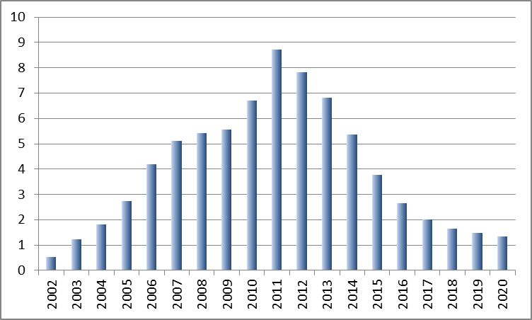
* The impact calculated according to formula (3.3). All analysed financial instruments are included. The fund investment included in the calculations comprises the fund financing, national public and private co-financing.
Source: authors’ calculations
The annual increase in real GDP caused by funds in the 2002-2020 period ranged from 0.5% to 8.7%, reaching its maximum in 2011 (the estimated impact on the main macroeconomic indicators is reported in table P.2 in the appendix). Average annual real GDP increase attributable to the funds is 3.9%; which may be compared with the European Commission’s estimated average annual increase of 6% over the period 2004-2020 (Gáková et al, 2009). Their estimate is based on a HERMIN type model and suggests that the impact of the EU funds in Latvia is the highest among the EU member states. The fact that our model suggests a lower impact is at least partially due to the assumption of 30% crowing out.
On the supply side, the funds had the greatest impact on value added in construction (5.3% over 2002 – 2020) and in private services (5.0% on average, see Fig 3.2). The strong impact on construction output is due to both the fact that this sector directly received notable amount of funds and to the fact that overall growth of investment caused by the inflow of the funds, mostly contributes to boosting output growth in this sector. The strong impact of the funds on private services is due to the fact that the funds contribute to growth of real wages, which in turn stimulates private consumption.
The estimated impact on agriculture in the end of the evaluation period deserves a special explanation. The estimated negative impact does not imply that the value added in this sector in the fund scenario is below that in the no-fund scenario (the opposite is true - according to our results, the level of real value added in this sector in 2020 in the fund scenario exceeds that in the no-fund scenario by 58%). The estimated negative impact indicates that the growth of the value added in the fund scenario in this period lags behind that in the no-fund scenario, which is due to the fact that at the end of the evaluation period growth of deflators in other sectors in the fund scenario exceeds growth of deflators in other sectors, which slows down growth of value added in agriculture.
Figure 3.2: Impact of the funds on real value added by sector in 2002 – 2020, assuming 30% crowding out, %*
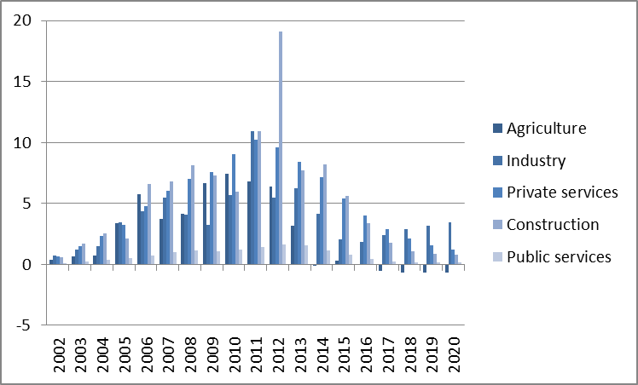
* The impact calculated according to formula (3.3). All analysed financial instruments are included. The fund investment included in the calculations comprises the fund financing, national public and private co-financing.
Source: authors’ calculations
On the demand side (see Fig 3.3) we estimate that the funds generate the strongest impact on private consumption (4.0% on average), being stimulated by an increase in real disposable income. Also, the funds have a strong positive impact on investment (4.0% on average). It should be noted that the estimated impact on investment in 2011 and 2012 is negative, which has an explanation similar to the explanation of the negative impact on agriculture above. The negative impact does not imply a lower level of investment in these years (in 2011, the level of investment in the funds scenario is 85% above the no-scenario baseline, but in 2012 – 76% above). The estimated negative impact implies a slowdown in growth of investment caused by the funds, which is due to a very high growth base: according to our estimation, in 2010 the funds boosted investment by 27%, being caused by a sharp increase in the funds inflow in 2010 (up by 56%), which generated a strong demand-side effect.
The impact on exports is quite modest (0.2% on average), which is due to the fact that apart from raising productivity the fund strongly contribute to the growth of real wages. While the impact on imports is much stronger (3.9% per annum on average), being boosted by a strong increase in both private consumption and investment.
Figure 3.3: Impact of the funds on real GDP by expenditure categories in 2002-2020, assuming 30% crowding out, %*
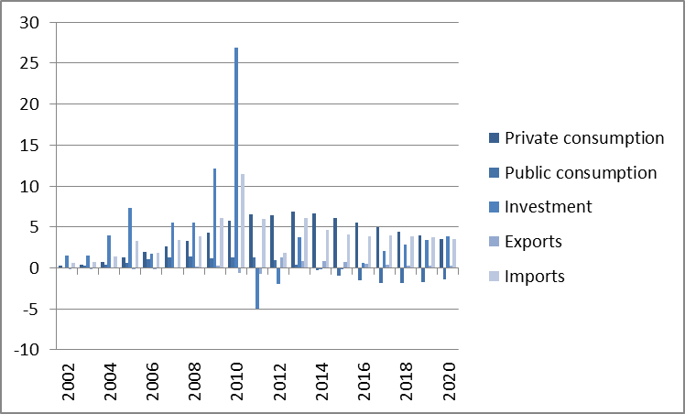
* The impact calculated according to formula (3.3). All analysed financial instruments are included. The fund investment included in the calculations comprises the fund financing, national public and private co-financing.
Source: authors’ calculations
The impact of the funds on the labour market (see Fig 3.4) shows itself in relatively moderate increase in employment (1.0% per annum on average), while the increase in productivity is much stronger (2.9% on average). The funds contribute to a reduction in unemployment, by 0.8 percentage points per annum on average. Estimated average annual increase in nominal and real wages amounts to 4.7% and 3.6%, respectively, while the maximum impact on wages (around 10%) is estimated in 2010, when there was a strong increase in the inflow of the funds; thus the strong increase in wages reflect the demand side effect.
Figure 3.4: Impact of the funds on nominal and real average wage (%), employment and labour productivity (%) and unemployment rate (percentage points) in 2002-2020, assuming 30% crowding out *
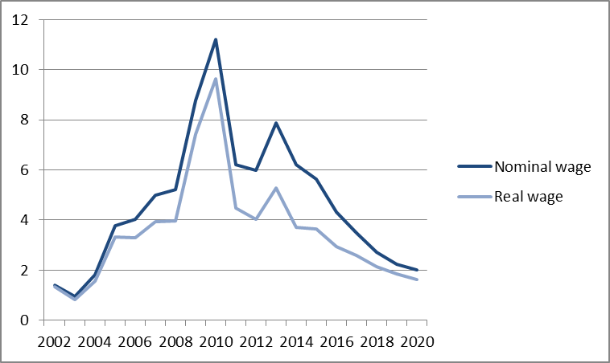 | 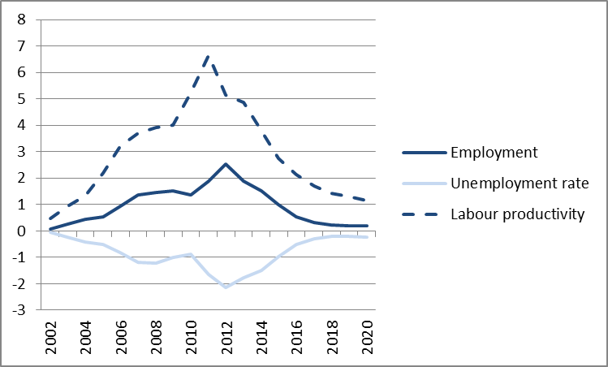
* The impact calculated according to formula (3.3). All analysed financial instruments are included. The fund investment included in the calculations comprises the fund financing, national public and private co-financing.
Source: authors’ calculations
The fund inflow is estimated to have a strong positive impact on budget tax and non-tax revenues (2.4% on average, see Fig 3.5). The estimated impact on consumer price index (CPI) is 1.1% per annum on average, while the maximum inflation impact (reaching 2.5%) is expected in 2012.
Figure 3.5: Impact of the funds on budget tax and non-tax revenues and on consumer price index in 2002-2020, assuming 30% crowding out, %*
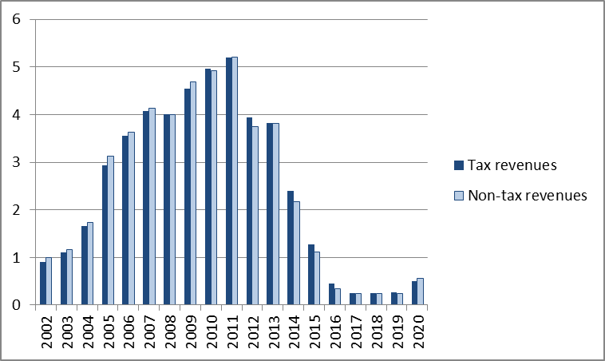 | 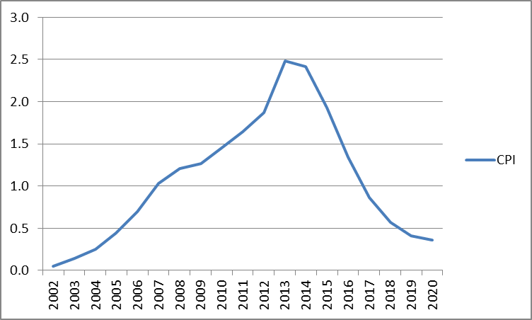
* The impact calculated according to formula (3.3). All analysed financial instruments are included. The fund investment included in the calculations comprises the fund financing, national public and private co-financing.
Source: authors’ calculations

The impact of funds by priority
In order to be able to use the fund data in a macro model, the data should be aggregated to macroeconomic variables. Macroeconomic modelling does not allow taking into account uniqueness of each project. In this study we as far as possible took into account the fact that investments are different by distinguishing between four types of investment (infrastructure, technology, human capital and physical capital), as well as by allocating the investments to one of the five sectors of the economy. Yet there is no doubt that even at this disaggregated level we have to make quite strong assumptions that investments attributed to a particular category have identical impact on macroeconomic variables. For example, investment in infrastructure includes both investments in physical and social infrastructure. Different kinds of training are pooled into one category. The aggregation of the fund data enables us to apply macroeconomic modelling to estimate the impact of the funds, yet this entails certain costs – namely, unavoidable loss of fund differentiation. This has to be kept in mind while interpreting the modelling results, especially when interpreting the impacts by investment priorities.
The impact of a particular priority is obtained by comparing the scenario which includes all funds with a scenario where the investments attributed to this priority are excluded. For example, in 2004-2006 planning period, the impact of technical assistance is estimated by comparing the following model simulations: (i) a simulation with all funds included and (ii) simulation with all funds except the technical assistance included. The difference between the two represents the estimated impact of the technical assistance.
Table 3.2 summarizes the calculated policy multipliers and returns to one invested lat in the 2004-2006 planning period by priority, assuming 30% crowding out.
Table 3.2: Return on fund investment by priority in the 2004-2006 planning period (assuming 30% crowding out) *
 | Policy multiplier |  | Return on one invested lat (LVL) | Priority ranking
 | 0% discount rate | 5% discount rate
The 2004-2006 planning period, total | 0.95 | 0.88 | 3.67
1. Promotion of territorial cohesion | 2.02 | 1.84 | 7.47 | 1
2. Promotion of enterprise and innovations | 0.64 | 0.59 | 2.56 | 2
4. Promotion of development of agriculture and fisheries | 0.51 | 0.49 | 2.31 | 3
3. Development of human resources and promotion of employment | 0.25 | 0.23 | 1.10 | 4
* Policy multiplier calculated as in equation (3.1), return to 1 invested lat calculated as in equation (3.2). 2004-2006 period funds include EU structural funds, INTERREG, Phare and SAPARD.
Source: authors’ calculations
According to the results, the highest return is on investment aimed at promotion of territorial cohesion (7.47 lats on 1 invested lat). The high return on this priority can be explained by the fact that this priority mainly comprises investment in infrastructure. The output of these investments – a better infrastructure – is not sector specific and is available for use in all sectors.
Other priorities mainly include investment in physical capital and human capital – investment, which is specific to the sector where it is made – which contributes to the relatively low return on investment made within these priorities.
As in the 2004-2006 planning period, the highest return in the 2007-2013 planning period is estimated on the priorities featuring high share of investment in infrastructure – namely, investment in transport (25.66 lats on 1 invested lat), investment in environmental protection and risk reduction (22.06 lats) and investment in information society (12.07, see Table 3.3).
Table 3.3: Return on fund investment by priority in the 2007-2013 planning period (assuming 30% crowding out) *
 |  | Policy multiplier |  |  |  | Return on one invested lat (LVL) |  | Priority ranking
 |  | 0% discount rate | 5% discount rate
The 2007-2013 planning period, total | 1.28 |  |  | 1.18 | 12.25
2.4. Transport | 2.28 |  |  | 2.09 | 25.66 |  | 1
2.6. Environmental protection and risk reduction | 1.41 |  |  | 1.40 | 22.06 |  | 2
2.3. Information society | 1.53 |  |  | 1.34 | 12.07 |  | 3
2.7. Human capital, employment, social integration | 1.33 |  |  | 1.15 | 10.38 |  | 4
2.1. Research and technology development | 1.22 |  |  | 1.03 | 5.74 |  | 5
2.8. Education | 0.60 |  |  | 0.51 | 4.28 |  | 6
2.2. Innovations and entrepreneurship | 0.43 |  |  | 0.38 | 4.12 |  | 7
2.5. Energy | 0.29 |  |  | 0.28 | 2.61 |  | 8
* Policy multiplier calculated as in equation (3.1), return to 1 invested lat calculated as in equation (3.2). 2007-2013 funds include EU structural funds, European Agricultural Fund for Rural Development, European Fisheries Fund, Objective 3 “Territorial Cooperation” of the EU Cohesion Policy, Norwegian Bilateral Financial Instrument and Swiss-Latvian cooperation programme.
Source: authors’ calculations
Another reason for the high return on investment in environmental protection and risk reduction is a high share of investment in physical infrastructure in industry, which is a capital-intensive sector. The estimated return on the priority “Human capital, employment, social integration” is 10.38 lats on one invested lat, which is fourth highest return. Although a substantial share of investment within the framework of this priority (23%) is investment in human capital, the priority also involves significant investment in social infrastructure, thus ensuring a significantly higher return than the 2004-2006 planning period priority “Development of human resources and promotion of employment”. Investment within the priority “Research and technology development” comprises investment in technology. Similar to investment in infrastructure, investment in technology generates a product that can be used by all sectors, but the relatively low return, is a result of the fact that introducing new technology to a production process takes time, while new infrastructure can be used more or less as soon as has been created.
The return on investment in education (4.28 lats), innovations and entrepreneurship (4.12 lats) and energy (2.61 lats) is relatively low, because sector specific investments prevail within these priorities: education priority consists of L-type expenditures, innovations and entrepreneurship and energy mainly of K-type expenditures.
Figures 3.6 and 3.7 show decomposition by priority of the fund impact on real GDP in the 2004-2006 planning period and the 2007 -2013 planning period, respectively. In the 2004-2006 planning period, contribution of priorities to real GDP growth was quite even over years: contribution of the 1st priority “Promotion of territorial cohesion” was the highest (57% of the fund induced GDP increase on average), contribution of the 2nd and 4th priorities was 19% and 16% on average, respectively, but contribution of the 3rd priority – around 3%.
Figure 3.6: Impact of the 2004-2006 planning period funds on real GDP in 2002-2011 by priority, assuming 30% crowding out, %*
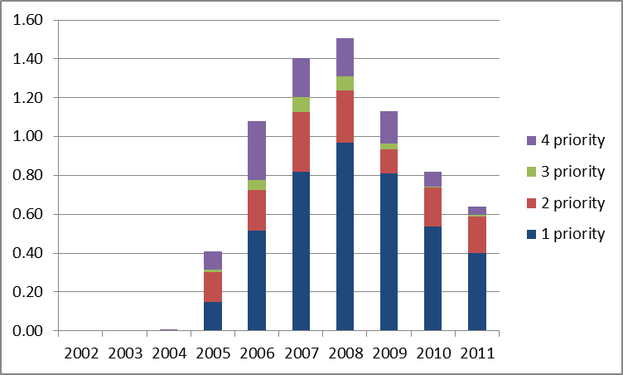
* The impact calculated according to formula (3.3). The fund investment included in the calculations comprises the fund financing, national public and private co-financing.
Source: authors’ calculations
In the 2007-2013 planning period, the priorities ensuring biggest contribution (43% of real GDP increase on average, see Fig 3.7) was the 4th priority “Transport”, the 6th priority “Environmental protection and risk reduction” (20%) and the 7th priority “Human capital, employment, social integration” (17%). The big contribution of these priorities is ensured both by their relatively high return and a large weight in total fund expenditures in the 2007-2013 planning period. Decomposition of the fund impact on real GDP by priority is summarized in tables P.3 and P.4 in the Annex.
Figure 3.7: Impact of the 2007-2013 planning period funds on real GDP in 2007-2020 by priority, assuming 30% crowding out, %*
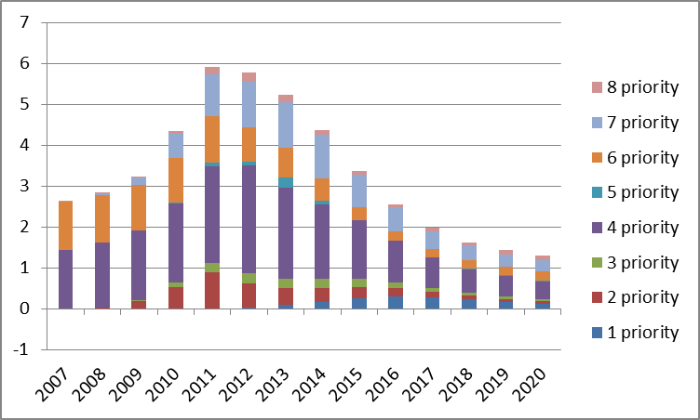
* The impact calculated according to formula (3.3). The fund investment included in the calculations comprises the fund financing, national public and private co-financing.
Source: authors’ calculations

Conclusions
The modelling exercise reported here suggests that investment co-financed from funds has generated a significant stimulating impact on economic activity, and it can be expected that this impact will continue. The impact has been estimated under alternative assumptions about the extent of crowding out: (i) assuming 15% crowding out, (ii) 30% (central scenario) and (iii) 50% crowding out. Since there is no unique internationally accepted way of summing up the return of the funds in a single indicator, we have calculated several alternative indicators that describe the impact of the funds. First, we calculated policy multipliers, which characterise the present value of accumulated annual GDP gains per one invested lat. Second, we have calculated the overall accrued impact on real GDP per one invested lat. And third, we have reported the estimated time paths of the fund impacts on the main macroeconomic variables. It should again be emphasised here that the ‘rates of return’ reported here cannot be interpreted as the same kind of rates of return that characterise investment in a micro-level project or in cost-benefit analysis.
Our results suggest that the policy multiplier in the 2004-2006 planning period (assuming 30% crowding out and a 5% discount rate) was 0.88, while the return on one invested lat amounted to 3.67 lats. The estimated policy multiplier in the 2007-2013 planning period is 1.18, but the return on one invested lat is 12.25. The funds have particularly promoted GDP growth in the crisis years, when the inflow of funds intensified strongly. According to our results, the maximum impact on real GDP (8.7%) has been achieved in 2011. On the supply side, the greatest positive impact can be observed in the private service and construction sectors, which can be explained by the funds’ positive effect on incomes, which stimulate private consumption and investment. Funds significantly increase labour productivity and real incomes, but the impact on consumer prices is moderate.
When looked at by priority, investment in promoting territorial cohesion (policy multiplier of 1.84, return on one invested lat of 7.47) had the greatest return in the 2004-2006 planning period, while investment in transport infrastructure (2.09 and 25.66, respectively) and environmental protection (1.40 and 22.06) achieved the highest return in the 2007-2013 planning period.
Policy recommendations
Our results suggest that the return on funds to a large extent depends on the mix of investment types, e.g., the return on investment in human capital can be increased by making simultaneous investment in development of infrastructure. However, it must be stressed that the use of the estimated returns on priorities to draw inferences for the future must be done very carefully, since an area where the return is high this period may not be equally good in the future. This is well known in general for the case of public infrastructure where the international evidence on the return to such investments suggests that it is much lower in rich, developed countries (which already have good infrastructure) than in less developed ones.
In order to create models that discriminate between different kinds of investments, both public and private, we need much more micro level information about these impacts. We do not have such information for Latvia. All we have is data from international studies at a rather aggregate level, which we have adapted to Latvian circumstances. It should also be stressed that a macroeconomic model does not allow taking into account uniqueness of each individual project, as it asks for aggregated funds data. The bottom line is that a macro model does only what a macro model can do, which is to evaluate macro policies and their impacts. The attempt to use it to select policy priorities can only be indicative.

Bibliography
Baltijas Starptautiskais Ekonomikas Politikas Studiju Centrs (BICEPS) (2008a). “ES fondu makroekonomiskās ietekmes izvērtējums. Otrā posma ziņojums,” Līgums Nr.FM 2007/ERAF – 5.2.3. – 2, Rīga, 2008. gada jūnijs.
Baltijas Starptautiskais Ekonomikas Politikas Studiju Centrs (BICEPS) (2008b). “ES fondu makroekonomiskās ietekmes izvērtējums. Pirmā posma ziņojums,” Pakalpojuma līgums Nr. FM 2007/ERAF – 5.2.3. – 2, Rīga, 2008. gada janvāris.
Bradley, J., Petrakos, G., Traistaru, J. (2005). „Integration, Growth, and Cohesion in an Enlarged European Union”, ZEI Studies in European Economics and Law, 2005.
Bradley, J., Kearney, I. Morgenroth, E. (2000). “Ex-ante Analysis of the Economic Impact of Pre-accession Structural Funds: A Model-based Methodology for Latvia,” The Economic and Social Research Institute (ESRI), Dublin.
Ederveen, S., Gorter, J., Mooij, R., Nahuis, R. (2003). "Funds and Games: The Economics of European Cohesion Policy," Occasional Papers 03, European Network of Economic Policy Research Institutes.
Gáková, Z., Grigonytė, D., Monfort, P. (2009). „A Cross-Country Impact Assessment of EU Cohesion Policy. Applying the Cohesion System of HERMIN Models”, Directorate-General for Regional Policy, Working Paper N° 01/2009.
Lolos, S. E. G. (2001). “The Macroeconomic Effect of EU Structural Transfers on the Cohesion Countries and Lessons for the CEECs,” IIASA, Interim Report IR-01-044/October.

Annex
Table P.1: Matching between priorities set in the terms of reference with priorities determined in EC Regulation No 1828/2006
No. | Priorities set in terms of reference | Priorities set in EC regulation No 1828/2006
1 | Research and technology development | Research and technology development – 01,02,03  Innovations and entrepreneurship – 04-09.
2 | Innovations and entrepreneurship
3 | Information society | Information society (10-15)
4 | Transport | Transport (16-32)
5 | Energy | Energy (33-43)
6 | Environmental protection and risk reduction | Environmental protection and risk reduction (44-54)
7 | Human capital, employment, social integration | Improving access to employment and sustainability (65-70)
 |  | Improving the social inclusion of less-favoured persons (71)
 |  | Tourism (55-57)
 |  | Culture (58-60)
 |  | Urban and rural regeneration (61)
 |  | Increasing the adaptability of workers and firms, enterprises and entrepreneurs (62-64)
 |  | Investment in social infrastructure (76- 79)
 |  | Mobilisation for reforms in the fields of employment and inclusion (80)
 |  | Strengthening institutional capacity at national, regional and local level (81)
 |  | Reduction of additional costs hindering the outermost regions development (82-84)
 |  | Technical assistance (85-86)
8 | Education | Codes ( 72-75)  * Education infrastructure (75)  * Design, introduction and implementation of reforms in education and training systems in order to develop employability, improving the labour market relevance of initial and vocational education and training, updating skills of training personnel with a view to innovation and a knowledge based economy (72)  * Measures to increase participation in education and training throughout the life-cycle, including through action to achieve a reduction in early school leaving, gender-based segregation of subjects and increased access to and quality of initial vocational and tertiary education and training (73)  * Developing human potential in the field of research and innovation, in particular through post-graduate studies and training of researches, and networking activities between universities, research centres and businesses (74).

Table P.2: The impact of fund investment on the main macroeconomic indicators in 2002-2020, assuming 30% crowding out, %, unless specified otherwise*
 | 2002 | 2003 | 2004 | 2005 | 2006 | 2007 | 2008 | 2009 | 2010
Real GDP | 0.5 | 0.9 | 1.3 | 2.2 | 3.2 | 3.7 | 3.9 | 4.0 | 5.2
Value added in constant prices:
Agriculture | 0.4 | 0.6 | 0.8 | 3.4 | 5.7 | 3.7 | 4.2 | 6.7 | 7.4
Industry | 0.8 | 1.2 | 1.5 | 3.4 | 4.4 | 5.5 | 4.1 | 3.2 | 5.7
Construction | 0.6 | 1.7 | 2.6 | 2.1 | 6.6 | 6.8 | 8.1 | 7.3 | 6.0
Private services | 0.6 | 1.5 | 2.3 | 3.3 | 4.7 | 6.0 | 7.0 | 7.6 | 9.1
Public services | 0.1 | 0.2 | 0.4 | 0.5 | 0.7 | 1.0 | 1.2 | 1.1 | 1.2
Nominal GDP | 0.6 | 1.5 | 2.3 | 3.7 | 5.5 | 7.2 | 7.9 | 8.2 | 9.6
GDP expenditure components in constant prices
Private consumption | 0.3 | 0.4 | 0.7 | 1.3 | 1.9 | 2.7 | 3.3 | 4.3 | 5.8
Public consumption | 0.1 | 0.3 | 0.4 | 0.7 | 1.0 | 1.3 | 1.4 | 1.2 | 1.3
Investment | 1.6 | 1.5 | 3.9 | 7.3 | 1.7 | 5.5 | 5.5 | 12.1 | 26.9
Exports of goods and services | -0.1 | -0.1 | 0.0 | -0.1 | -0.1 | 0.1 | 0.2 | 0.3 | -0.6
Imports of goods and services | 0.6 | 0.7 | 1.4 | 3.3 | 1.9 | 3.5 | 3.9 | 6.1 | 11.5
Number of persons employed | 0.1 | 0.3 | 0.5 | 0.5 | 0.9 | 1.4 | 1.5 | 1.5 | 1.4
Unemployment level, in percentage points | -0.1 | -0.2 | -0.4 | -0.5 | -0.8 | -1.2 | -1.2 | -1.0 | -0.9
Nominal monthly wage | 1.4 | 1.0 | 1.8 | 3.8 | 4.0 | 5.0 | 5.2 | 8.8 | 11.2
Real monthly wage, incl. | 1.4 | 0.8 | 1.6 | 3.3 | 3.3 | 3.9 | 4.0 | 7.4 | 9.6
In agriculture | 0.3 | 1.0 | 1.6 | 3.6 | 7.5 | 7.1 | 7.0 | 8.6 | 10.2
In industry | 0.2 | 0.7 | 1.4 | 2.3 | 4.1 | 5.5 | 6.9 | 6.5 | 6.7
In construction | 0.3 | 0.9 | 1.4 | 1.5 | 3.6 | 4.2 | 5.0 | 5.0 | 4.7
In private services | 0.3 | 0.9 | 1.4 | 1.9 | 2.6 | 3.6 | 4.0 | 4.2 | 4.6
In public services | 0.1 | 0.5 | 0.9 | 1.4 | 1.9 | 2.6 | 3.4 | 3.8 | 4.0
Labour productivity, incl. | 0.5 | 0.9 | 1.3 | 2.2 | 3.2 | 3.7 | 3.9 | 4.0 | 5.2
In agriculture | 0.4 | 0.7 | 0.8 | 3.6 | 6.3 | 3.1 | 3.9 | 6.8 | 7.4
In industry | 0.7 | 1.1 | 1.4 | 3.3 | 4.1 | 5.2 | 4.1 | 3.5 | 6.0
In construction | 0.3 | 0.8 | 1.2 | 1.2 | 3.8 | 3.5 | 5.2 | 5.2 | 5.1
In private services | 0.5 | 1.0 | 1.4 | 2.0 | 2.9 | 3.6 | 4.0 | 4.2 | 5.2
In public services | 0.1 | 0.2 | 0.4 | 0.5 | 0.7 | 1.0 | 1.2 | 1.1 | 1.2
Tax revenue of the government budget | 0.9 | 1.1 | 1.7 | 2.9 | 3.6 | 4.1 | 4.0 | 4.5 | 5.0
Non-tax revenue of the government budget | 1.0 | 1.2 | 1.7 | 3.1 | 3.6 | 4.1 | 4.0 | 4.7 | 4.9
Consumer price index | 0.1 | 0.1 | 0.3 | 0.4 | 0.7 | 1.0 | 1.2 | 1.3 | 1.4
* Impact calculated as in equation (3.3)
Source: authors’ calculations

Table P.2 (continuation): The impact of fund investment on the main macroeconomic indicators in 2002-2020, assuming 30% crowding out, %, unless specified otherwise.*
 | 2011 | 2012 | 2013 | 2014 | 2015 | 2016 | 2017 | 2018 | 2019 | 2020
Real GDP | 8.7 | 7.8 | 6.8 | 5.4 | 3.8 | 2.7 | 2.0 | 1.7 | 1.5 | 1.3
Value added in constant prices:
Agriculture | 6.8 | 6.4 | 3.2 | -0.1 | 0.3 | 0.0 | -0.5 | -0.7 | -0.7 | -0.7
Industry | 10.9 | 5.5 | 6.3 | 4.1 | 2.1 | 1.9 | 2.4 | 2.9 | 3.2 | 3.4
Construction | 10.9 | 19.1 | 7.7 | 8.2 | 5.6 | 3.4 | 1.8 | 1.1 | 0.8 | 0.8
Private services | 10.2 | 9.6 | 8.4 | 7.1 | 5.4 | 4.0 | 2.9 | 2.1 | 1.6 | 1.2
Public services | 1.4 | 1.6 | 1.5 | 1.2 | 0.8 | 0.4 | 0.2 | 0.2 | 0.2 | 0.2
Nominal GDP | 12.8 | 12.5 | 11.8 | 10.0 | 7.6 | 5.6 | 4.3 | 3.5 | 3.1 | 2.8
GDP expenditure components in constant prices
Private consumption | 6.5 | 6.5 | 6.9 | 6.6 | 6.1 | 5.5 | 4.9 | 4.4 | 3.9 | 3.5
Public consumption | 1.3 | 0.9 | 0.4 | -0.3 | -1.0 | -1.6 | -1.9 | -1.9 | -1.7 | -1.4
Investment | -4.9 | -2.0 | 3.8 | -0.1 | -0.2 | 0.6 | 2.1 | 2.9 | 3.4 | 3.9
Exports of goods and services | -0.7 | 1.3 | 0.8 | 0.8 | 0.8 | 0.5 | 0.4 | 0.3 | 0.3 | 0.3
Imports of goods and services | 5.9 | 1.9 | 6.1 | 4.6 | 4.1 | 3.9 | 4.0 | 3.9 | 3.7 | 3.6
Number of persons employed | 1.9 | 2.5 | 1.9 | 1.5 | 1.0 | 0.5 | 0.3 | 0.2 | 0.2 | 0.2
Unemployment level, in percentage points | -1.7 | -2.1 | -1.8 | -1.5 | -1.0 | -0.5 | -0.3 | -0.2 | -0.2 | -0.2
Nominal monthly wage | 6.2 | 6.0 | 7.9 | 6.2 | 5.6 | 4.3 | 3.5 | 2.7 | 2.3 | 2.0
Real monthly wage, incl. | 4.5 | 4.0 | 5.3 | 3.7 | 3.6 | 2.9 | 2.6 | 2.1 | 1.8 | 1.6
In agriculture | 9.9 | 12.1 | 9.1 | 4.9 | 3.7 | 2.9 | 1.7 | 1.1 | 0.8 | 0.8
In industry | 9.8 | 11.6 | 11.2 | 10.9 | 9.0 | 6.8 | 5.6 | 4.8 | 4.4 | 4.3
In construction | 8.4 | 11.1 | 6.7 | 8.1 | 6.3 | 4.7 | 3.7 | 2.9 | 2.1 | 1.6
In private services | 5.5 | 5.7 | 5.1 | 3.7 | 2.8 | 1.7 | 1.1 | 0.9 | 0.7 | 0.6
In public services | 4.7 | 5.3 | 4.9 | 4.4 | 3.7 | 2.8 | 2.0 | 1.5 | 1.2 | 0.9
Labour productivity, incl. | 6.6 | 5.1 | 4.9 | 3.8 | 2.7 | 2.1 | 1.7 | 1.4 | 1.3 | 1.1
In agriculture | 5.7 | 5.8 | 2.4 | -0.5 | 0.9 | 1.0 | 0.5 | 0.3 | 0.2 | 0.2
In industry | 10.8 | 5.2 | 7.0 | 4.8 | 2.8 | 2.8 | 3.0 | 3.2 | 3.4 | 3.5
In construction | 8.5 | 9.4 | 7.3 | 8.6 | 6.7 | 5.2 | 3.9 | 2.8 | 2.0 | 1.5
In private services | 5.7 | 4.9 | 4.3 | 3.6 | 2.6 | 1.9 | 1.3 | 1.0 | 0.7 | 0.6
In public services | 1.4 | 1.6 | 1.5 | 1.2 | 0.8 | 0.4 | 0.2 | 0.2 | 0.2 | 0.2
Tax revenue of the government budget | 5.2 | 3.9 | 3.8 | 2.4 | 1.3 | 0.5 | 0.3 | 0.2 | 0.3 | 0.5
Non-tax revenue of the government budget | 5.2 | 3.8 | 3.8 | 2.2 | 1.1 | 0.3 | 0.2 | 0.2 | 0.2 | 0.6
Consumer price index | 1.6 | 1.9 | 2.5 | 2.4 | 1.9 | 1.3 | 0.9 | 0.6 | 0.4 | 0.4
* Impact calculated as in equation (3.3)
Source: authors’ calculations

Table P.3: Impact of funds of the 2004-2006 planning period on GDP in 2002-2011, assuming 30% crowding out.*
 | 2002 | 2003 | 2004 | 2005 | 2006 | 2007 | 2008 | 2009 | 2010 | 2011
Return on funds of the first planning period, incl. | 0.00 | 0.00 | 0.01 | 0.41 | 1.12 | 1.48 | 1.59 | 1.20 | 0.86 | 0.67
1.1. Promotion of territorial cohesion | 0.00 | 0.00 | 0.00 | 0.15 | 0.52 | 0.82 | 0.97 | 0.81 | 0.54 | 0.40
1.2. Promotion of enterprise and innovations | 0.00 | 0.00 | 0.00 | 0.15 | 0.21 | 0.31 | 0.27 | 0.13 | 0.20 | 0.19
1.3. Development of human resources and promotion of employment | 0.00 | 0.00 | 0.00 | 0.01 | 0.05 | 0.08 | 0.08 | 0.03 | 0.00 | 0.01
1.4. Promotion of development of agriculture and fisheries | 0.00 | 0.00 | 0.00 | 0.09 | 0.30 | 0.20 | 0.19 | 0.17 | 0.08 | 0.04
1.5. Technical assistance | 0.00 | 0.00 | 0.00 | 0.01 | 0.03 | 0.06 | 0.07 | 0.06 | 0.04 | 0.03
* Impact calculated according to equation (3.3)
Source: authors’ calculations
Table P.4: Impact of funds of the 2007-2013 planning period on GDP in 2007-2020, assuming 30% crowding out.*
 | 2007 | 2008 | 2009 | 2010 | 2011 | 2012 | 2013 | 2014 | 2015 | 2016 | 2017 | 2018 | 2019 | 2020
Returns of funds of the second planning period, incl. | 2.70 | 2.92 | 3.38 | 4.78 | 6.77 | 6.53 | 5.92 | 4.77 | 3.40 | 2.45 | 1.85 | 1.50 | 1.30 | 1.15
2.1. Research and technology development | 0.00 | 0.00 | 0.00 | 0.00 | 0.01 | 0.04 | 0.09 | 0.17 | 0.26 | 0.29 | 0.29 | 0.23 | 0.18 | 0.13
2.2. Innovations and entrepreneurship | 0.00 | 0.03 | 0.19 | 0.53 | 0.89 | 0.58 | 0.41 | 0.35 | 0.28 | 0.21 | 0.14 | 0.09 | 0.07 | 0.05
2.3. Information society | 0.00 | 0.00 | 0.02 | 0.11 | 0.22 | 0.25 | 0.24 | 0.23 | 0.19 | 0.13 | 0.09 | 0.07 | 0.06 | 0.05
2.4. Transport | 1.44 | 1.59 | 1.69 | 1.92 | 2.36 | 2.63 | 2.22 | 1.81 | 1.43 | 1.03 | 0.74 | 0.58 | 0.50 | 0.44
2.5. Energy | 0.00 | 0.00 | 0.00 | 0.03 | 0.09 | 0.10 | 0.25 | 0.08 | -0.01 | 0.00 | 0.01 | 0.02 | 0.02 | 0.02
2.6. Environmental protection and risk reduction | 1.18 | 1.16 | 1.13 | 1.10 | 1.13 | 0.83 | 0.73 | 0.56 | 0.33 | 0.22 | 0.20 | 0.20 | 0.21 | 0.22
2.7. Human capital, employment, social integration | 0.01 | 0.05 | 0.17 | 0.60 | 1.01 | 1.12 | 1.11 | 1.07 | 0.80 | 0.59 | 0.44 | 0.35 | 0.30 | 0.27
2.8. Education | 0.00 | 0.00 | 0.01 | 0.07 | 0.20 | 0.23 | 0.17 | 0.12 | 0.09 | 0.07 | 0.07 | 0.09 | 0.10 | 0.12
* Impact calculated according to equation (3.3)
Source: authors’ calculations

In the current programming period Latvia receives funds under the Convergence objective of EU Cohesion Policy and in the post-2013 period will receive funding a less developed region i.e. as a result of having GDP per capita at less the 75% of the EU average.
More detailed information on the methodology used for classifying funds is available in the second appendix to the report of the first deliverable.
Arguably, if there were no funds the resources used for co-financing would have largely been invested anyway.
This evaluation covers the following financial instruments: European Social Fund, European Regional Development Fund, Cohesion Fund/ISPA, European Agricultural Fund for Rural Development, European Fisheries Fund, European pre-accession financial instruments Phare and SAPARD, INTERREG, Objective 3 “Territorial Cooperation” of the EU Cohesion Policy (ERAF), financial instrument of the European Economic Area, Norwegian Bilateral Financial Instrument, Swiss-Latvian cooperation programme.
This is exactly what policy was aimed at after the onset of the recession when the use of EU funds was accelerated and switched towards activities with a more immediate impact.

